**Module (CSS and CSS 3) -2**

**Q-1. What are the benefits of using CSS?**

**Ans:** The following benefits of using CSS are:

**1. Consistency and Global Styling**

CSS ensures a consistent visual identity throughout a website or multiple web pages. By employing a single external CSS file, it becomes possible to maintain a cohesive style, minimizing duplication and simplifying global styling updates.

### **2. Easier to Maintain and Efficient Updates**

The separation of content and style in the CSS simplifies the process of maintaining web pages and implementing updates. By modifying a few lines of code in the central CSS file, you can quickly adjust fonts, colors, and layouts without the need to edit each HTML element. This results in a more efficient and hassle-free maintenance process.

### **3. Time-Saving and Faster Loading Times**

Utilizing external CSS files allows web browsers to cache the styling information, resulting in more efficient and faster page load times. This optimization greatly enhances the overall user experience, especially for returning visitors.

### **4. Enhanced Design Options and Responsive Design**

CSS offers diverse design possibilities and enables responsive web design, adapting to various screen sizes and devices. It is crucial to ensure your website looks and functions well on different platforms.

### **5. SEO-Friendly**

Employing clean and structured CSS code can enhance your website’s search engine optimization. By making your code more readable for search engine crawlers CSS can potentially boost your site’s search rankings, leading to increased visibility and traffic.

### **6. Accessibility and Print-Friendly Pages**

CSS allows for better web accessibility and the creation of printer-friendly versions of web pages, making your content more inclusive and suitable for printing. It is valuable for e-commerce websites, blogs, and content-heavy platforms by making it easy to create print-friendly versions of web pages. This feature caters to users who may wish to print articles or product details, delivering a seamless and convenient experience for your audience.

### **7. Platform Independence and Device Compatibility**

CSS ensures your designs remain consistent across different devices and platforms, enhancing the user experience and making your site accessible to a broader audience.

### **8. CSS Minification and Page Load Efficiency**

Minimizing CSS file sizes leads to quicker page load times, essential for retaining visitors and delivering a seamless browsing experience.

### **9. Cascade, Inheritance, and Class/ID Usage**

CSS empowers you to create versatile designs through cascading styles, inheritance, and precise class/ID usage, allowing for efficient styling and layout control.

### **10. CSS Sprites, Animations, and Effects**

Advanced CSS techniques enable you to optimize graphics and create dynamic visuals, including animations and interactive effects, without relying on complex scripting languages. This enhances the user experience and engagement on your website.

**Q-2. What are the disadvantages of CSS?**

**ANS: The disadvantages of CSS** **are following**:

### 1. Cross-Browser Issues and Browser Compatibility

CSS might not always look the same across different web browsers. This can lead to inconsistencies in how your website appears to users. Developers often have to write special CSS code for each browser or use something called vendor prefixes to make sure everything looks as it should.

### 2. Learning Curve

Another hurdle is the learning curve. CSS, while essential, can be complex, especially if you’re just starting. To master CSS, you need to grasp things like selectors, properties, values, and the box model, which can be overwhelming for beginners.

### 3. Security Concerns

Unlike some other web technologies, CSS doesn’t come with built-in security features. If misused, it can even become a security vulnerability, prone to attacks like Cross-Site Scripting (XSS). This means developers need to be careful when using CSS to avoid potential security risks. To maintain security, developers should clean and validate user-generated CSS input to prevent potential vulnerabilities like XSS attacks.

### 4. Complex Layouts and Limited Layout Control

CSS has its limitations when it comes to controlling intricate web layouts. Achieving specific designs, like making columns of equal height, can be a bit tricky without employing workarounds or turning to other technologies like Flexbox or Grid.

### 5. File Size and Performance Impact

Extensive or poorly optimized CSS files can make your web pages load slowly. To keep your website performing at its best, it is crucial to keep your CSS as minimal and optimized as possible.

### 6. Over-Specificity and Overriding Styles

The way CSS works can sometimes lead to unexpected styling conflicts. This happens because CSS is “cascading,” meaning styles can pile up and sometimes override each other in unexpected ways. Managing these conflicts can be challenging.

### 7. Maintenance Challenges

As websites grow and evolve, maintaining and reorganizing CSS can become quite complex and time-consuming. It is essential to stick to best practices and use naming conventions to keep your styles manageable.

**Q-3. What is the difference between CSS2 and CSS3?**

**ANS: Difference between CSS and CSS3:**

| **S.NO** | **CSS** | **CSS3** |
| --- | --- | --- |
| **1.** | CSS is capable of positioning texts and objects. | On the other hand, CSS3 is capable of making the web page more attractive and takes less time to create. CSS3 is backward compatible with CSS. |
| **2.** | Responsive designing is not supported in CSS | CSS3 is the latest version, hence it supports responsive design. |
| **3.** | CSS cannot be split into modules. | Whereas CSS3 can be breakdown into modules. |
| **4.** | Using CSS, we cannot build 3D animation and transformation. | But in CSS3 we can perform all kinds of animation and transformations as it supports animation and 3D transformations. |
| **5.** | CSS is very slow as compared to CSS3 | Whereas CSS3 is faster than CSS. |
| **6.** | In CSS we have set of standard colours and it uses basic colour schemes only. | Whereas CSS3 has a good collection of HSL RGBA, HSLA, and gradient colours. |
| **7.** | In CSS we can only use single text blocks. | But in CSS3 we can use multi-column text blocks |
| **8.** | CSS does not support media queries. | But CSS3 supports media queries |
| **9.** | CSS codes are not supported by all types of modern browsers. | Being the latest version, CSS3 codes are supported by all modern browsers. |
| **10.** | CSS was developed in 1996. | CSS3 is the latest version of CSS and was released in 2005. |
| **11.** | There is no special effect like shadowing text, text animation, etc. in CSS. The animation was coded in jQuery and JavaScript. | CSS3 has many advance features like text shadows, visual effects, and a wide range of font styles and colours. |
| **12.** | CSS is memory intensive. | CSS3 memory consumption is low as compared to CSS. |

**Q-4 Name a few CSS style components.**

**ANS: A few CSS style components are:**

**<style>**

**.class{**

**background-color: red;**

**text-align: center;**

**font-size: 20px;**

**color: blue;**

**font-style:italic;**

**font-weight:bold;**

**}**

**</style>**

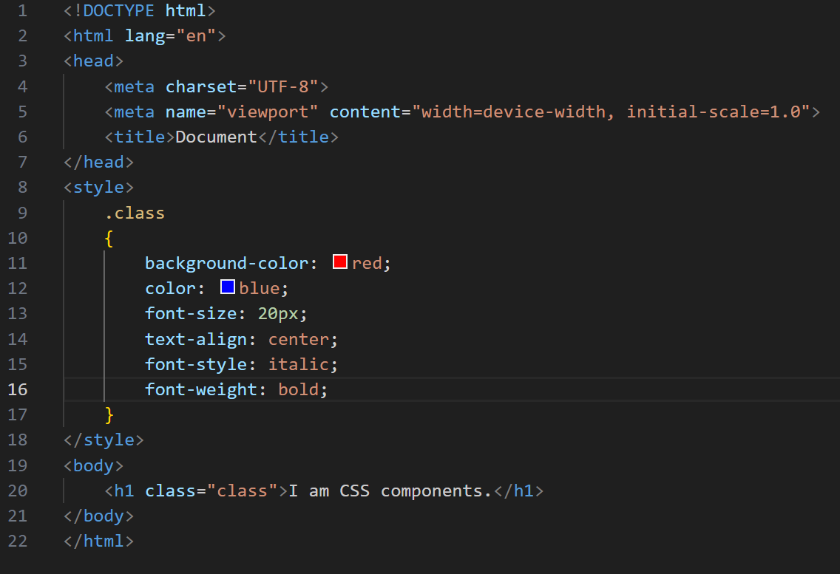 **Ex:**

**Q-5. What do you understand by CSS opacity?**

**ANS:** The opacity property sets the opacity level for an element.The opacity-level describes the transparency-level, where 1 is not transparent at all, 0.5 is 50% see-through, and 0 is completely transparent. When using the opacity property to add transparency to the background of an element, all of its child elements become transparent as well. This can make the text inside a fully transparent element hard to read.

**Example:**

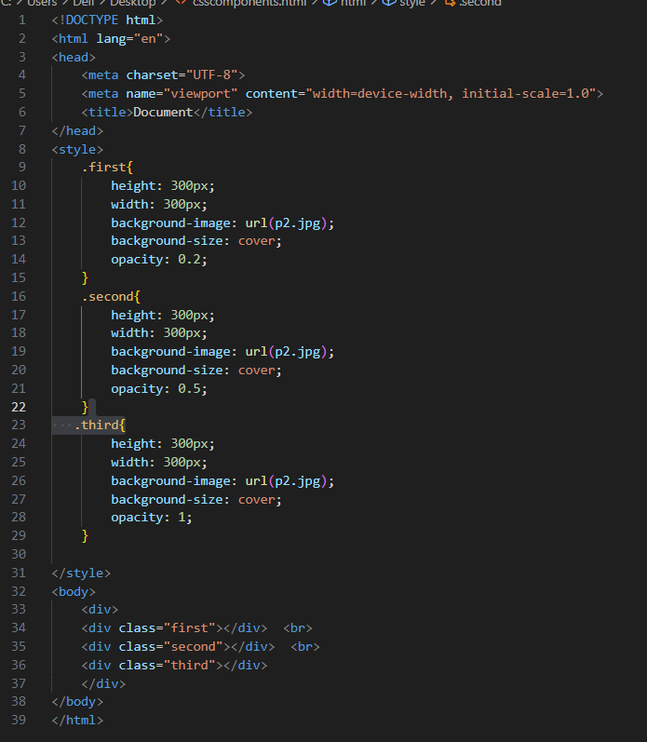

**Output:**

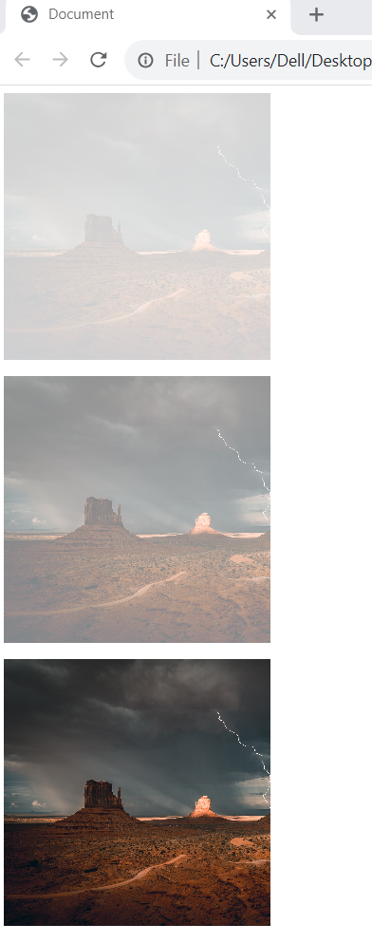

**Q-6. How can the background color of an element be changed?**

**Ans:** Yes, the background color of an element can be changed by using the background-color property of css.

**Example:**

**Output:**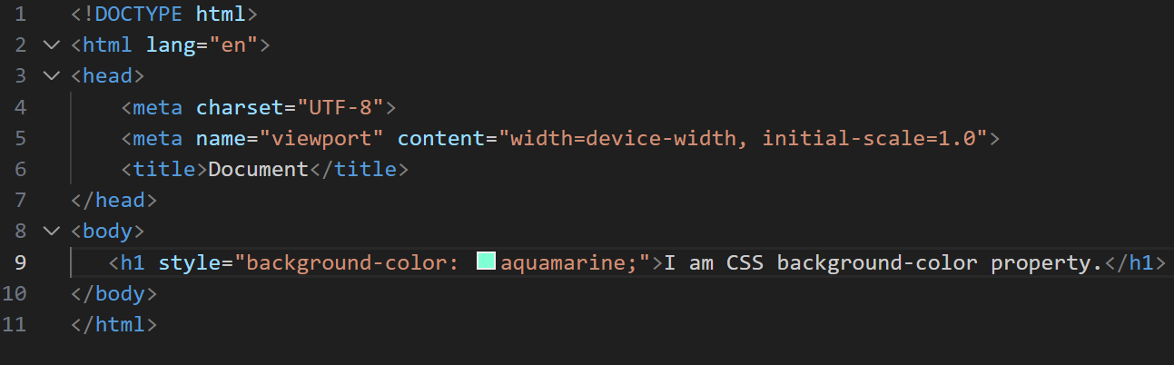



**Q-7. How can image repetition of the backup be controlled?**

**Ans:** Image repetition of the backup be controlled by using background-repeat property of CSS.

**Example:**

**Q-8. What is the use of the background-position property?**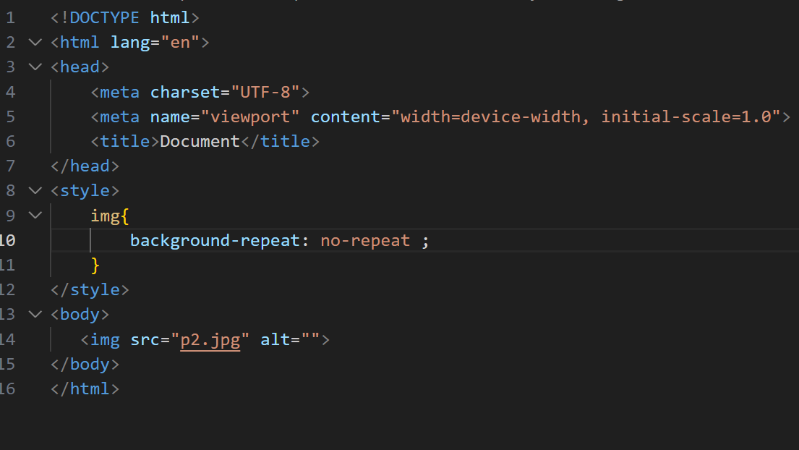

**Ans:**The background-position property sets the starting position of a background image. By default, a background-image is placed at the top-left corner of an element, and repeated both vertically and horizontally.

**Syntax:** background-position:value;

**Property values:**

| **Values** | **Description** |
| --- | --- |
| left top  left center  left bottom  right top  right center  right bottom  center top  center center  center bottom | If you only specify one keyword, the other value will be "center" |
| *x% y%* | The first value is the horizontal position and the second value is the vertical. The top left corner is 0% 0%. The right bottom corner is 100% 100%. If you only specify one value, the other value will be 50%. Default value is: 0% 0% |
| *xpos ypos* | The first value is the horizontal position and the second value is the vertical. The top left corner is 0 0. Units can be pixels (0px 0px) or any other CSS units. If you only specify one value, the other value will be 50%. You can mix % and positions |
| *initial* | Sets this property to its default value. |
| *inherit* | Inherits this property from its parent element. |

**Example:**

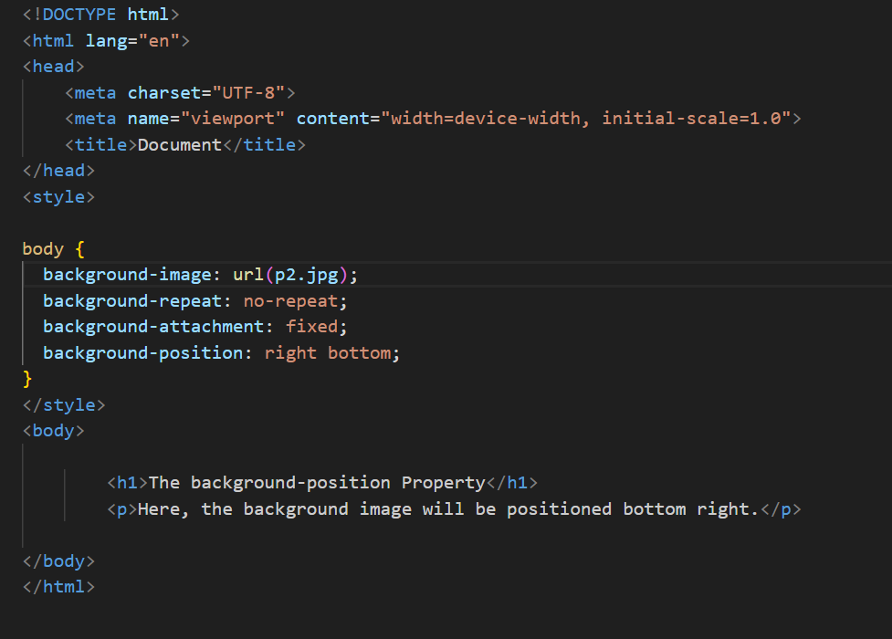

**Q-9. Which property controls the image scroll in the background?**

**Ans:** The background-attachment property controls the image scroll in the background.

**Syntax:**

background-attachment: scroll|fixed|local|initial|inherit;

Example:

## **Property Values:**

| **Values** | **Description** |
| --- | --- |
| scroll | The background images will scroll with the page.This is default. |
| fixed | The background image will not scroll with the page |
| local | The background image will scroll with the element’s content. |
| Initial | Sets this property to its default value. |
| inherit | Inherit this property from its parent element. |

**Example :** 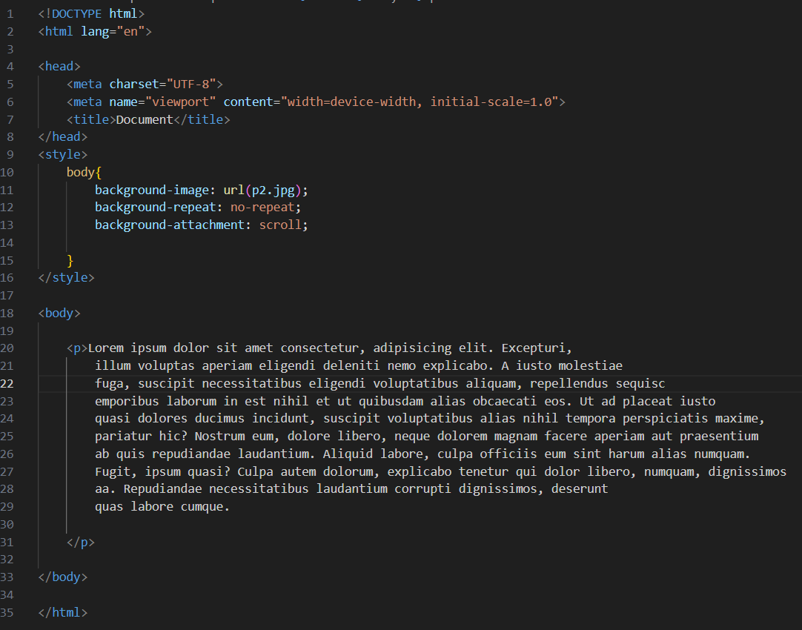

**Q-10. Why should background and color be used as separate properties?**

**Ans: The color property in CSS is used to set the color of text, the background of the webpage, and also to set the color of borders, when** the CSS background properties are used to add background effects for elements.

**Example:**

**Color property:**

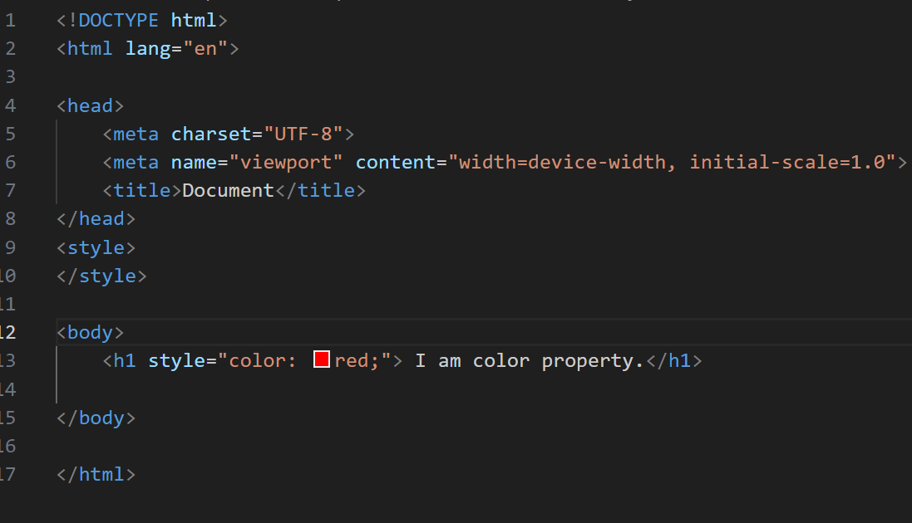

**Output:**



**Background property:**

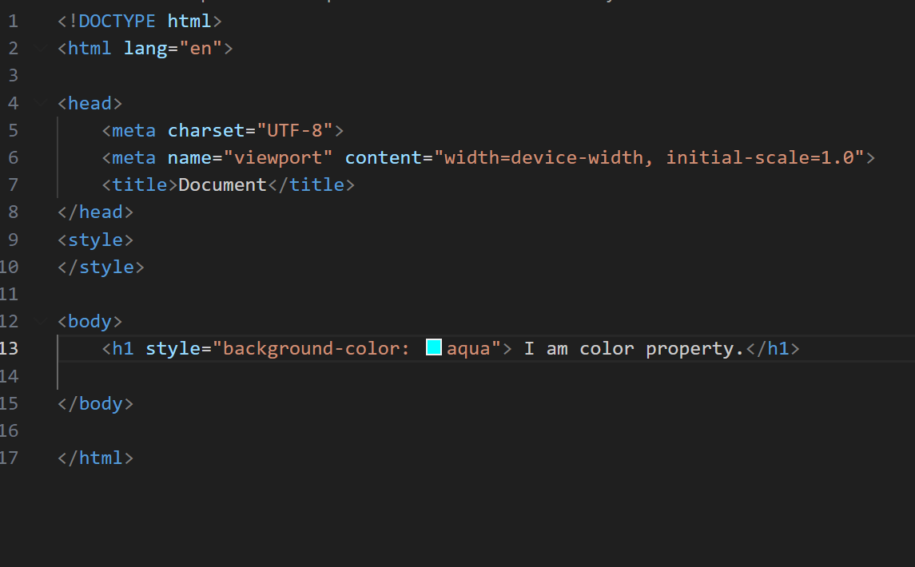

**Output:**

**Q-11.How to center block elements using CSS1?** 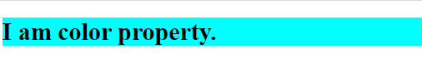

**Ans:For center bock elements using CSS The text-align property is used to set the horizontal alignment of a text.A text can be left or right aligned, centered, or justified.**

**Syntax:**

Text-align:value;

**Example:**

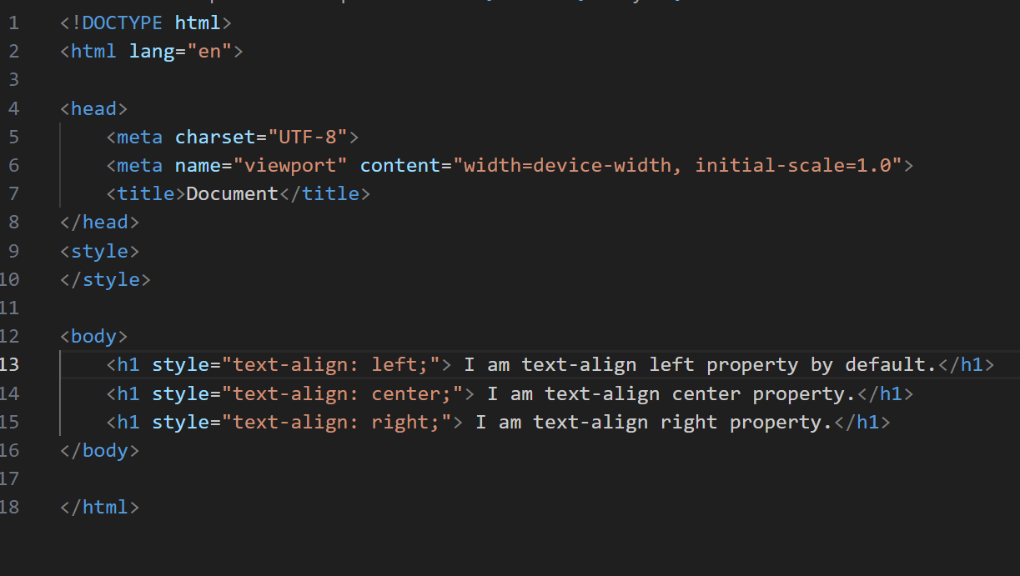

**Output:**

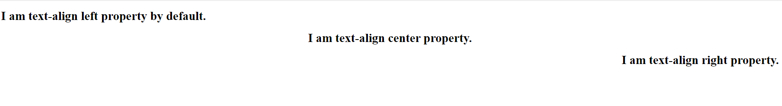

**Q-12.How to maintain the CSS specifications?**

**Ans:**The maintain the CSS specifications by using internal,inline,external selectors, pseudo class and element.

**Example:**

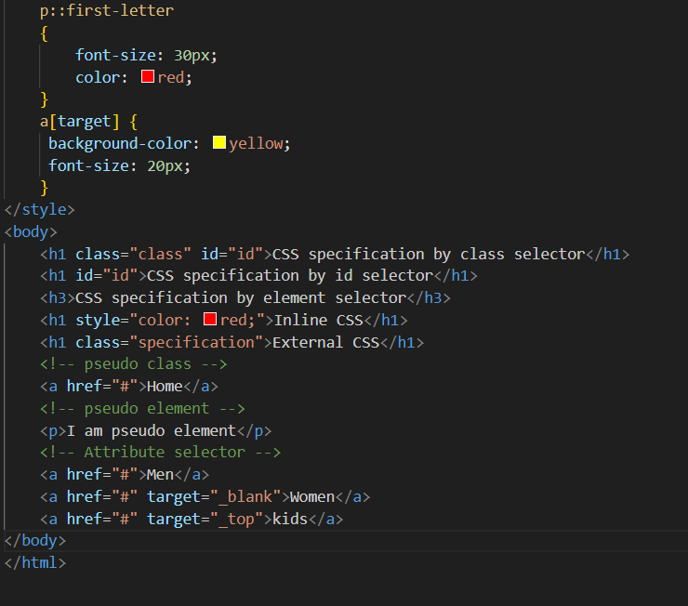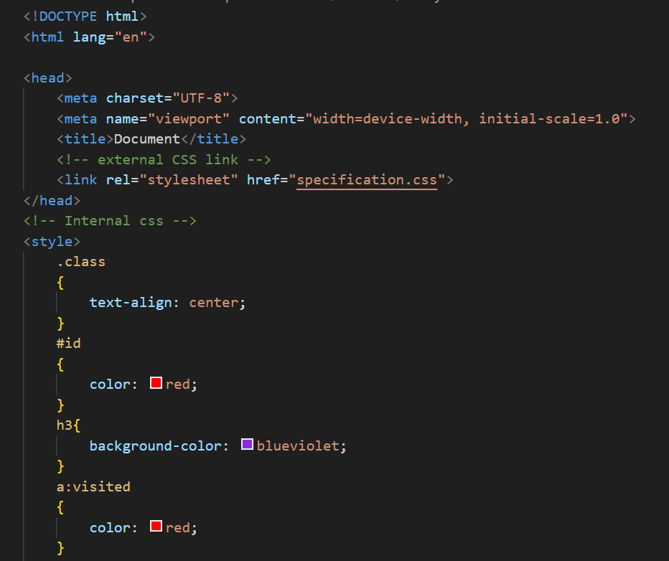

**Output:**

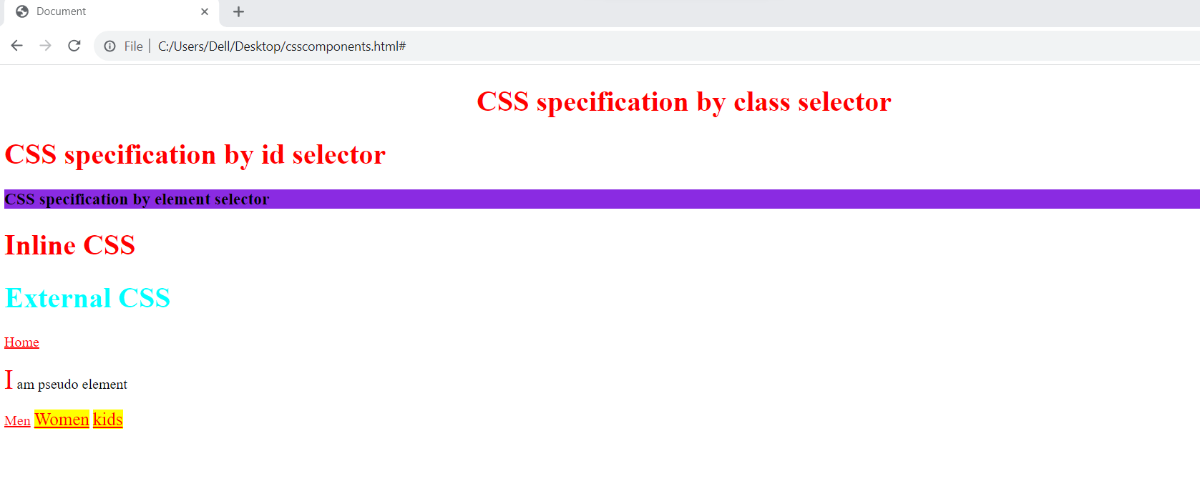

**Q-13. What are the ways to integrate CSS as a web page?**

**Ans:There are three ways to integrate CSS as a web page:**

**(a).Inline CSS:** An inline style may be used to apply a unique style for a single element.To use inline styles, add the style attribute to the relevant element. The style attribute can contain any CSS property.

**(b).External CSS:** With an external style sheet, you can change the look of an entire website by changing just one file!Each HTML page must include a reference to the external style sheet file inside the <link> element, inside the head section.

**(c).Internal CSS:** An internal style sheet may be used if one single HTML page has a unique style.The internal style is defined inside the <style> element, inside the head section.

**Example:**

**(A).inline CSS:**

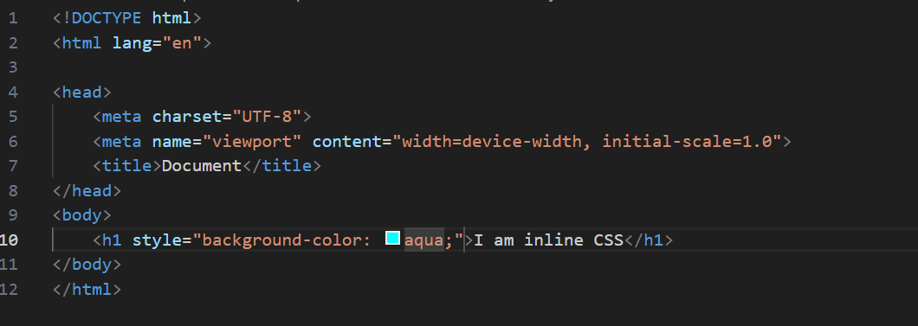

**Output:**

**(B).External CSS:**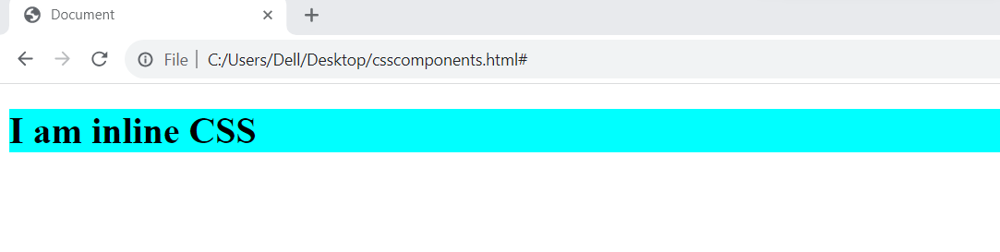

**This file save with .css extension, ex:external.css.**

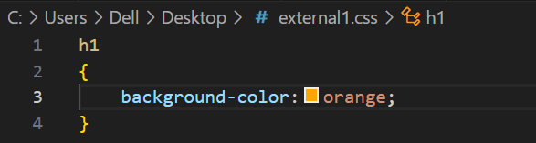

**This file save with .html extension.**

**Output:**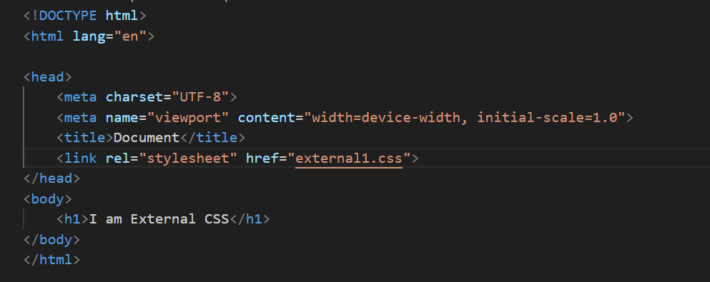

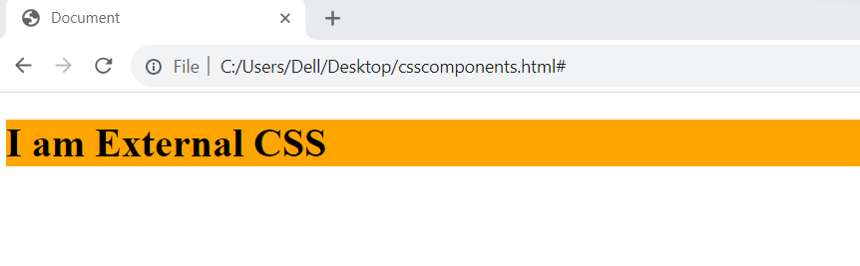

**(c).Internal CSS:**

**Output:**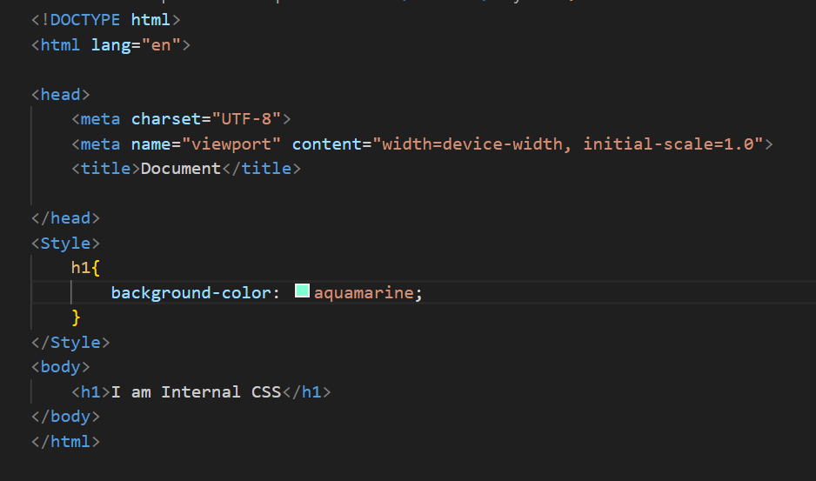

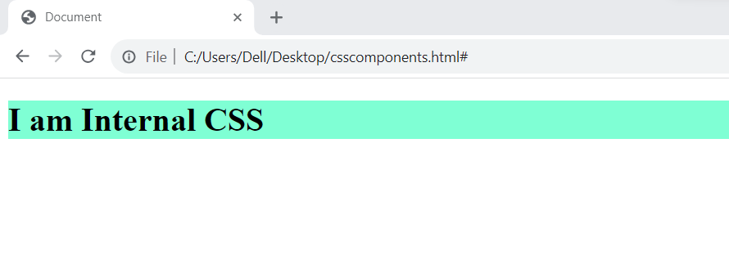

**Q-14. What is embedded style sheets?**

**Ans:**Embedded style sheets refer to when you embed style sheet information into an HTML document using the <style> element. You do this by embedding the style sheet information within <style></style> tags in the head of your document.

Embedded style sheets are particularly useful for HTML documents that have unique style requirements from the rest of the documents in your project. However, if the styles need to be applied across multiple documents, you should link to an external style sheet instead of using individual embedded style sheets. Using embedded stylesheets holds a distinct advantage over inline styles which only allow you to address one HTML element at a time.

**Syntax:** The CSS syntax for embedded style sheets is exactly the same as other CSS code, apart from the fact that it is now wrapped within the <style></style> tags. The <style> tag takes the ‘type’ attribute that defines the type of style sheet being used (ie. text/CSS).

**Example:**

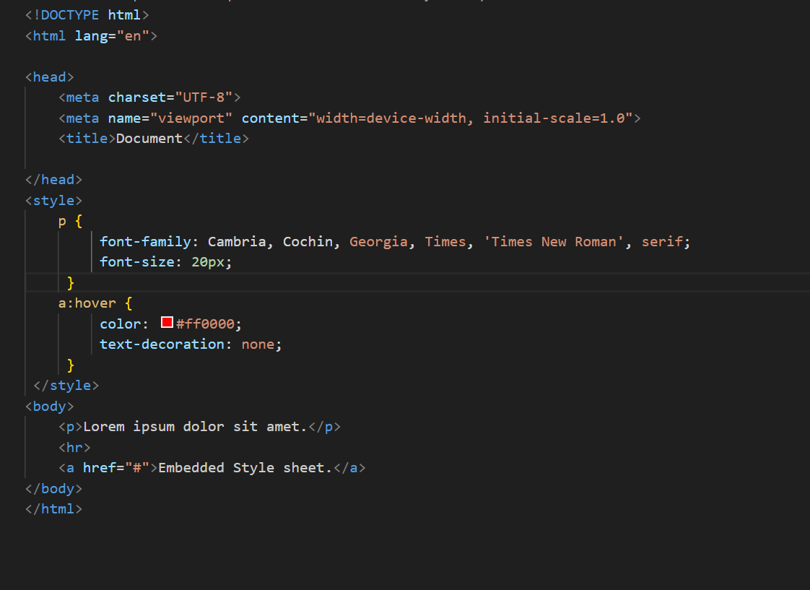

**Output:**

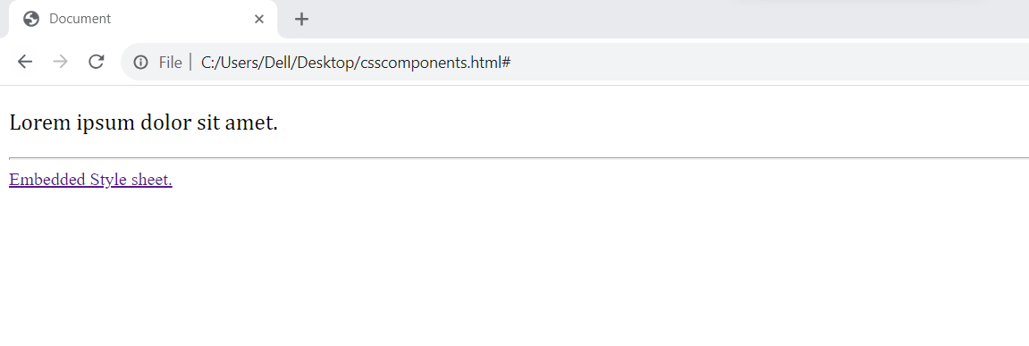

**Q-15. What are the external style sheets?**

**Ans:**Definition: External CSS is used to style multiple HTML pages with a single style sheet. External CSS contains a separate CSS file with a **.css** extension. The CSS file contains style properties added on selectors (For example class, id, heading, … etc.).

## **How to Link a CSS File to an HTML File ?**

To link a CSS file to an HTML file, use the **<link>** element within the HTML file’s **<head> section** with the **rel** attribute set to “**stylesheet**” and the **href** attribute specifying the CSS file’s path.

CSS property is written in a separate file with a .css extension and should be linked to the HTML document using a link tag. External CSS sets styles for elements once and applies them consistently across multiple web pages, ensuring a unified design.

**Example :**

**This is external css file with .css extension.**

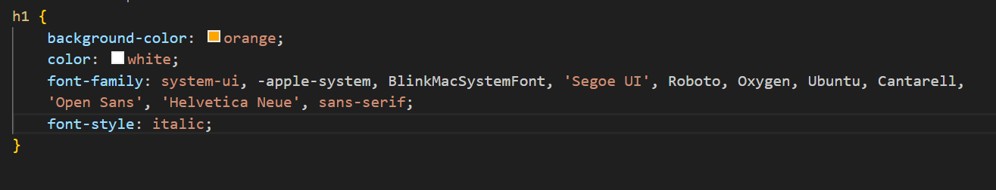

**This is html file in link above css file.**

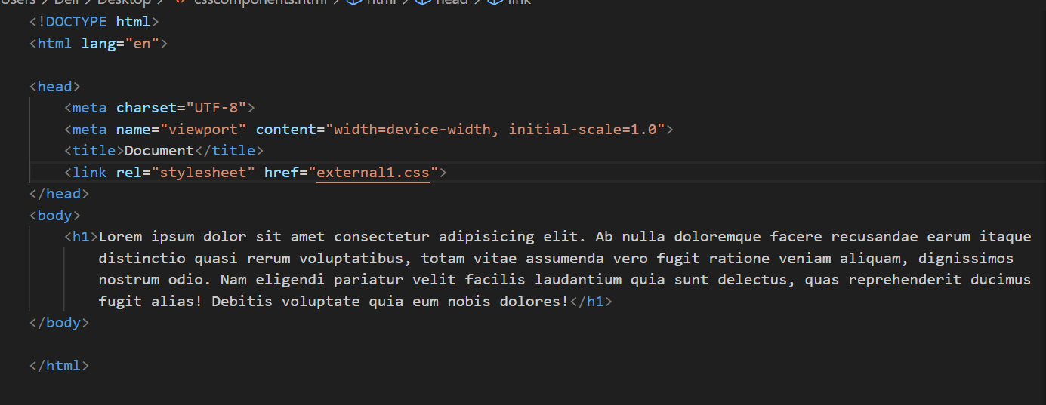

**Output:**

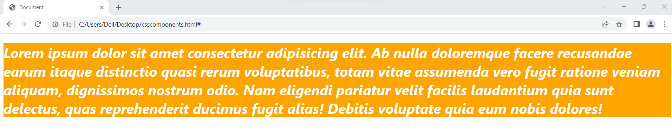

**Q-16. What are the advantages and disadvantages of using external style sheets?**

**Ans:Advantages of External CSS**

* Improved maintainability and code organization.
* Enhanced reusability across multiple HTML files.
* Efficient caching and faster page load times.

## **Disadvantages of External CSS**

* Pages may not render correctly until the external CSS is loaded.
* Uploading or linking to multiple CSS files may increase your site’s download time, affecting its overall performance.
* Large-scale projects may face versioning and caching challenges when using external CSS

**Q-17. What is the meaning of the CSS selector?**

**Ans:**A CSS selector selects the HTML element(s) for styling purposes. CSS selectors select HTML elements according to their id, class, type, attribute, etc.

**CSS selectors:** There are many basic different types of selectors.

* **Simple Selector:** It is used to select the HTML elements based on their element name, id, attributes, etc.
* Element Selector
* ID selector
* Class selector
* **Group Selector**
* **Universal selector**
* **Attribute selector**
* **Pseudo-class selector**
* **Pseudo-element selector**

**Q-18. What are the media types allowed by CSS?**

**Ans:**There are three media types allowed by CSS.

**CSS media types:**

| **Value** | **Description** |
| --- | --- |
| All | Used for all media type devices. |
| print | Used for print preview mode |
| screen | Used for computer screens, tablets, smart-phones etc. |

**Q-19. What is the rule set?**

**Ans:**A CSS rule set is various affirmations to various pieces or elements of the document. The objective is to apply a bunch of properties for certain distinct qualities to a solitary, or a particular arrangement of components in the connected HTML page.

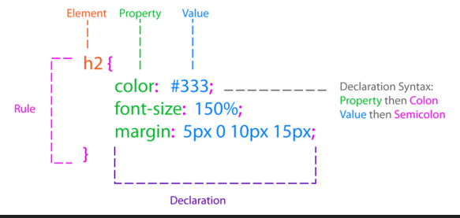

**Q-20. Create Layouts.**

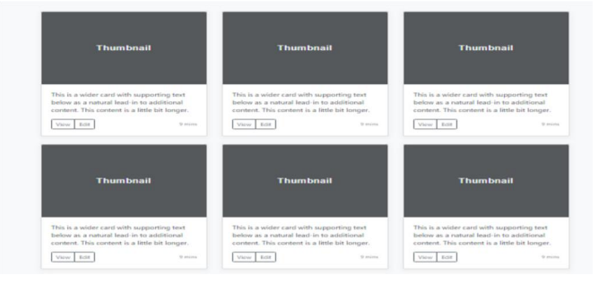

**Ans:**

**Code :**

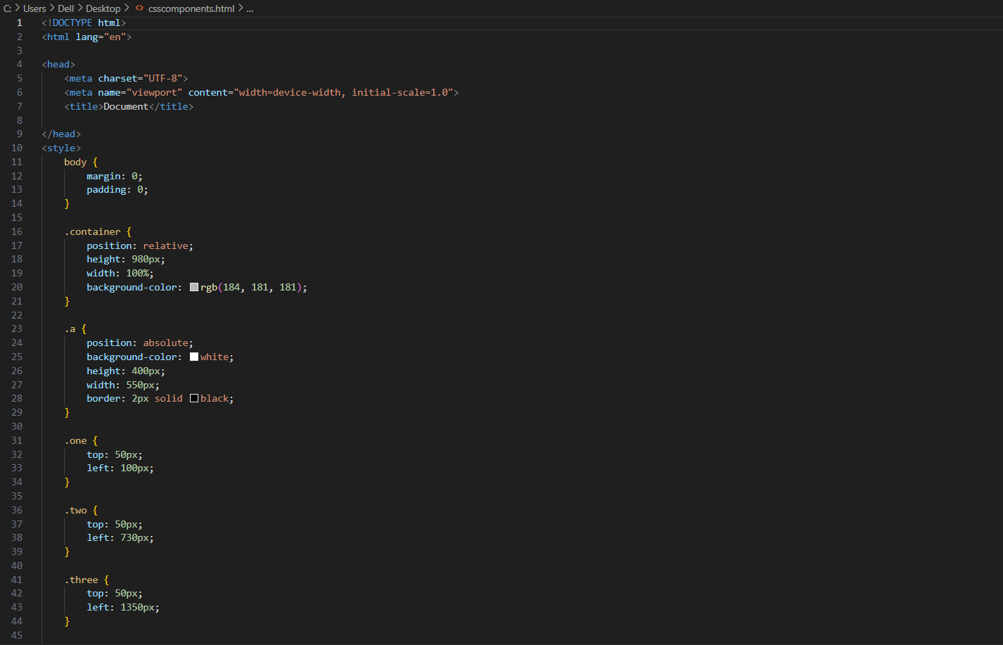

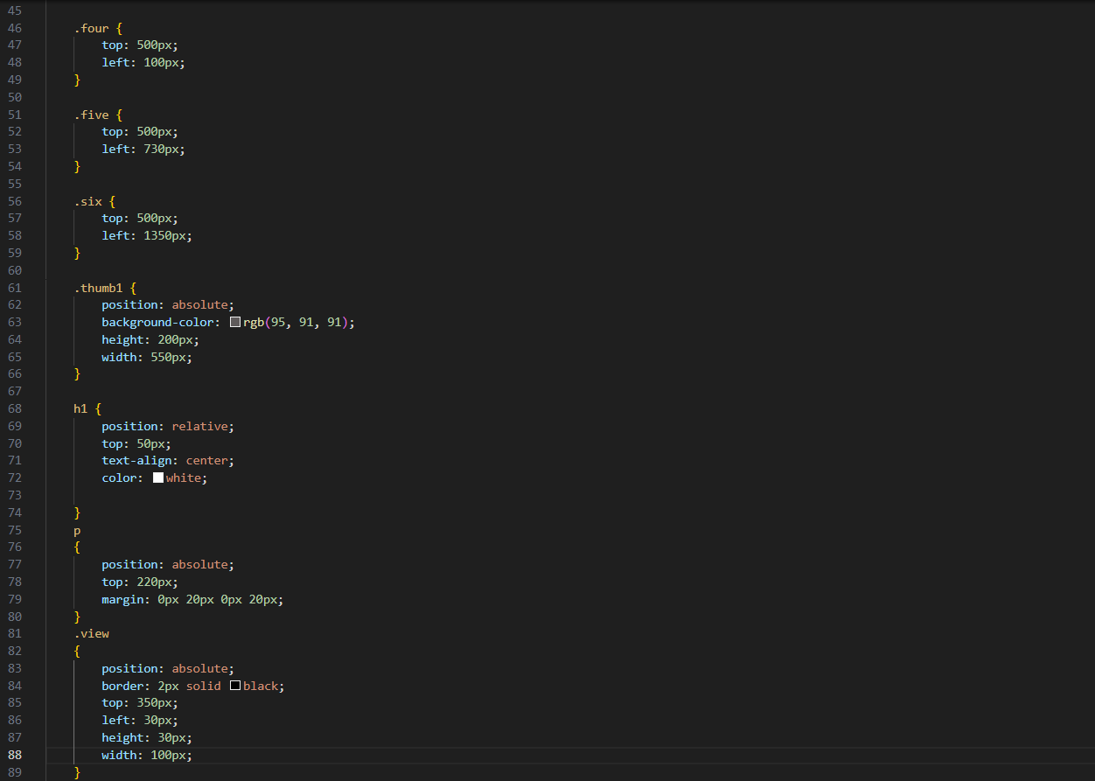

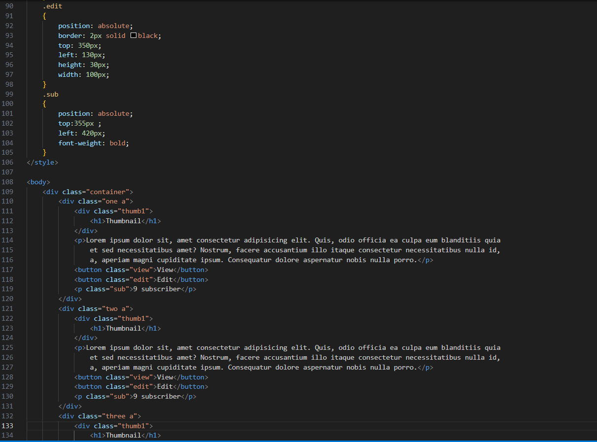

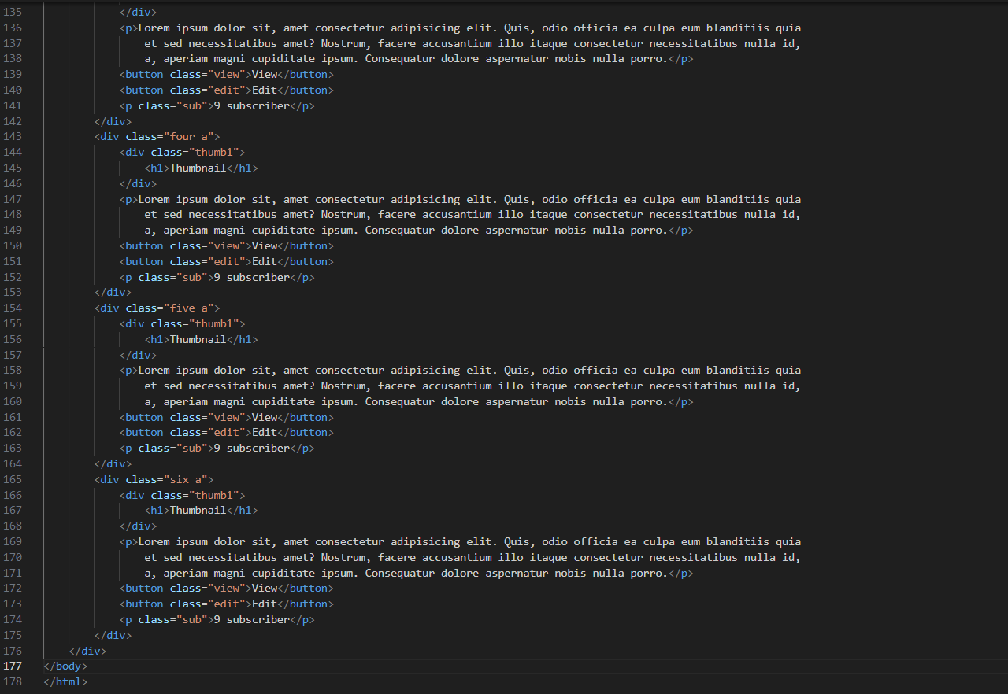

**Output:**

